Discovering Jesus as a family - Session 2

Welcome back! In the last session we saw how God made his world, and it was perfect! This session, we find out what went wrong.

Starter activity
Spend some time, each making your own picture that you can be proud of.
Now pass it to the youngest member of your family, and allow them to destroy it!
How do you feel?
Video
Now watch the video and see how that’s what Adam and Eve did to God’s beautiful world.
https://www.youtube.com/watch?v=Kg2lkCxjMg8
Outside activity
Now go outside with two bags. Feel free to make it a competition if that helps!
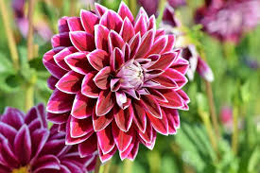
In Bag 1 – put any perfect leaves, flowers, berries … that you can find.
In Bag 2 – put any broken, damaged, dead ones.
As you can see, the Fall has affected all of creation, not just people. Now there are weeds, things eat each other, and everything dies.
All because of Adam and Eve!
What about our part?
God’s rules for us
Just like Adam and Eve, God has rules for us too. We call them the 10 commandments. Have a look at the attached pictures, [insert PDF] and see if you can work out what the commands are. (Page 2 has the words, and Page 3 the answers!)
How have you done on keeping his rules?
Target practice!
Have a go at throwing a ball into a bucket (rolled up paper will do!)
How many times did you miss?
In King Henry VIII times, the word for this kind of “miss” was “sin”, and Christians still use this word today, for all the times we miss God’s targets, or break his rules.
Final video
Watch this video to see what happens when we break God’s rules, how it breaks our relationship with him.
Then in Session 3 we meet Jesus – the answer to the problem!
Bubble Prayers
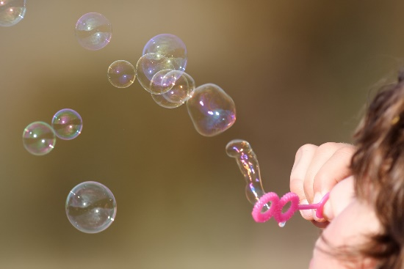
Take a bottle of bubbles. Have another look at the 10 commandment pictures. Choose one that you are aware of breaking. As you blow some bubbles, say Sorry to God for the commandment you have broken. As the bubbles pop, thank God that through Jesus you are forgiven, and he has forgotten all about it!

